# Linux Fundamentals Part 3

# Task 1: Introduction:

# Join the room Linux Fundamentals Part 3

# 

# Task 2: Deploy Your Linux Machine:

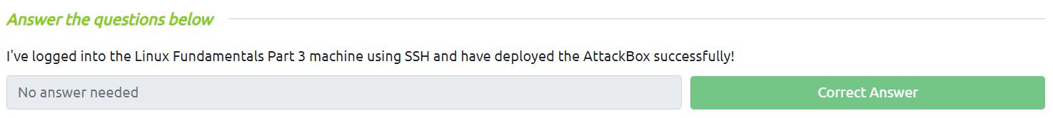

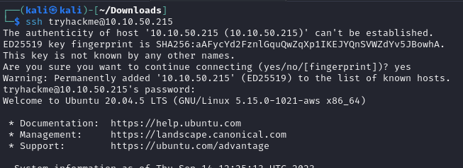

**Task 3: Terminal Text Editors**

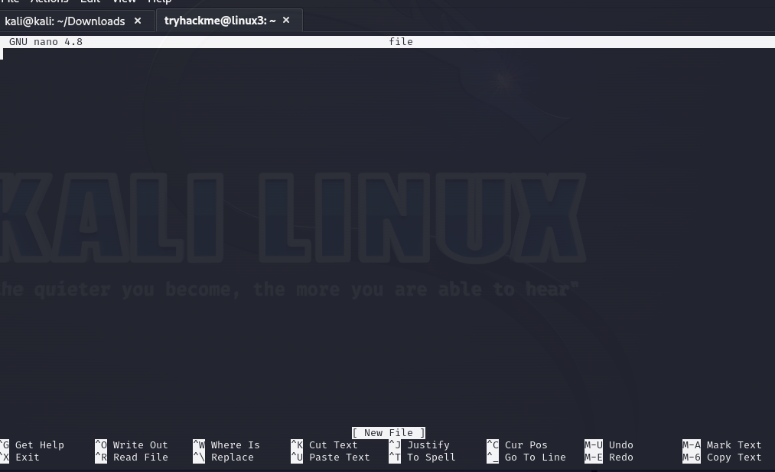

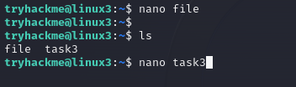

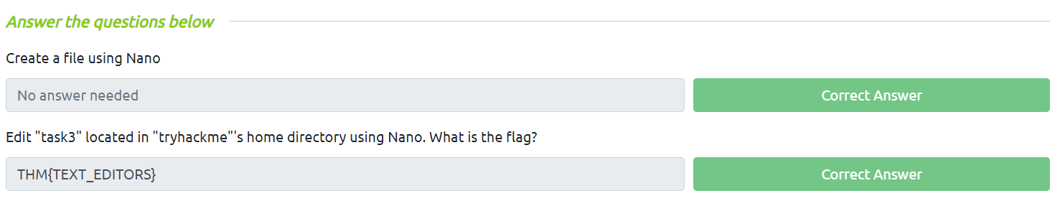

**Task 4: General/Useful Utilities:**

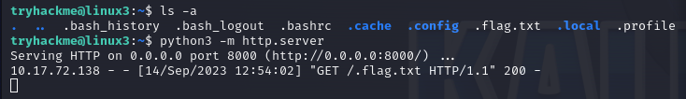

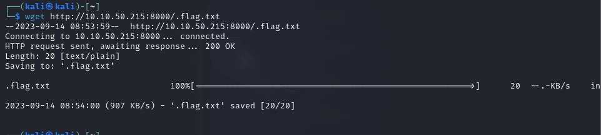

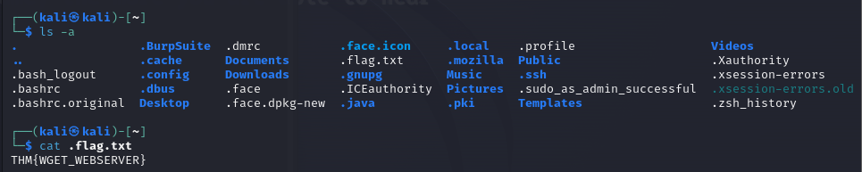

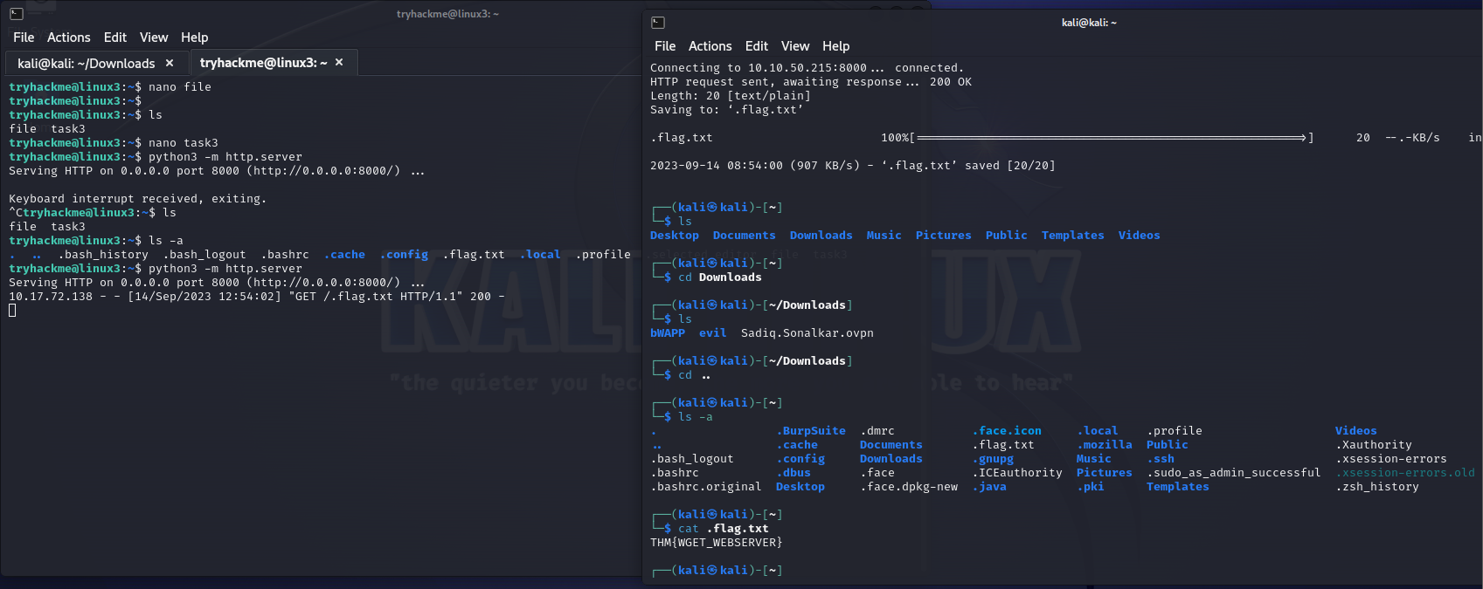

**I created a file in tryhackme:**

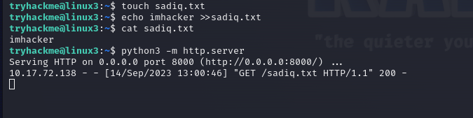

**I retrieved the file in my machine:**

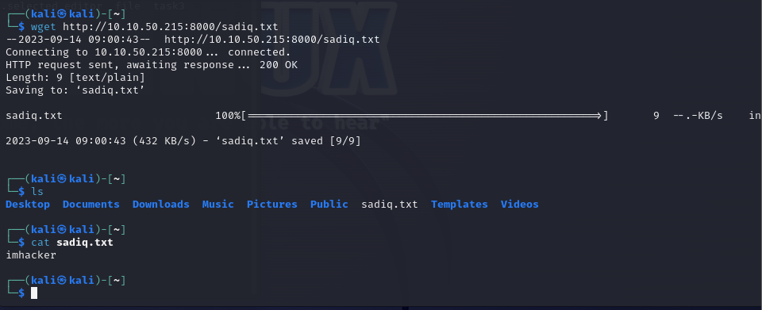

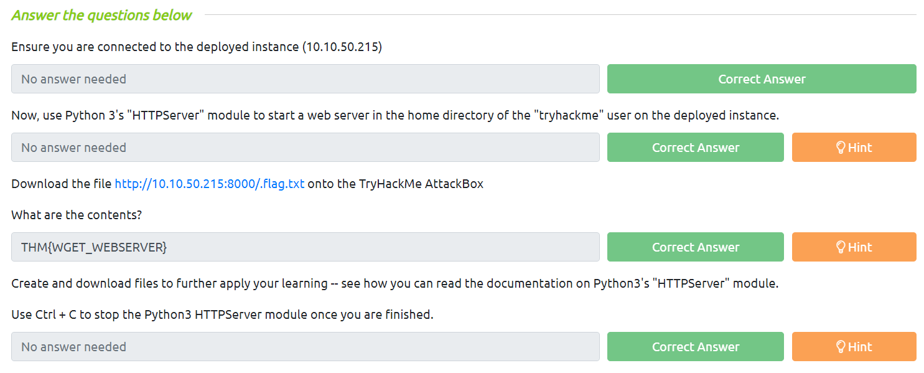

**Task 5: Processes 101:**

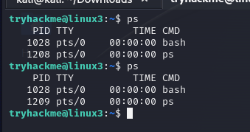

Ps aux

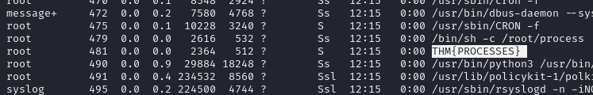

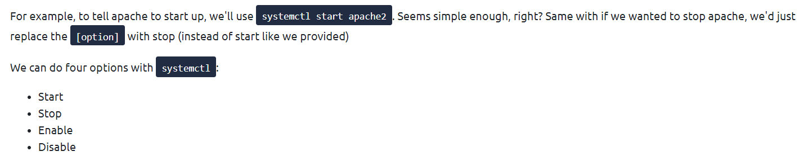

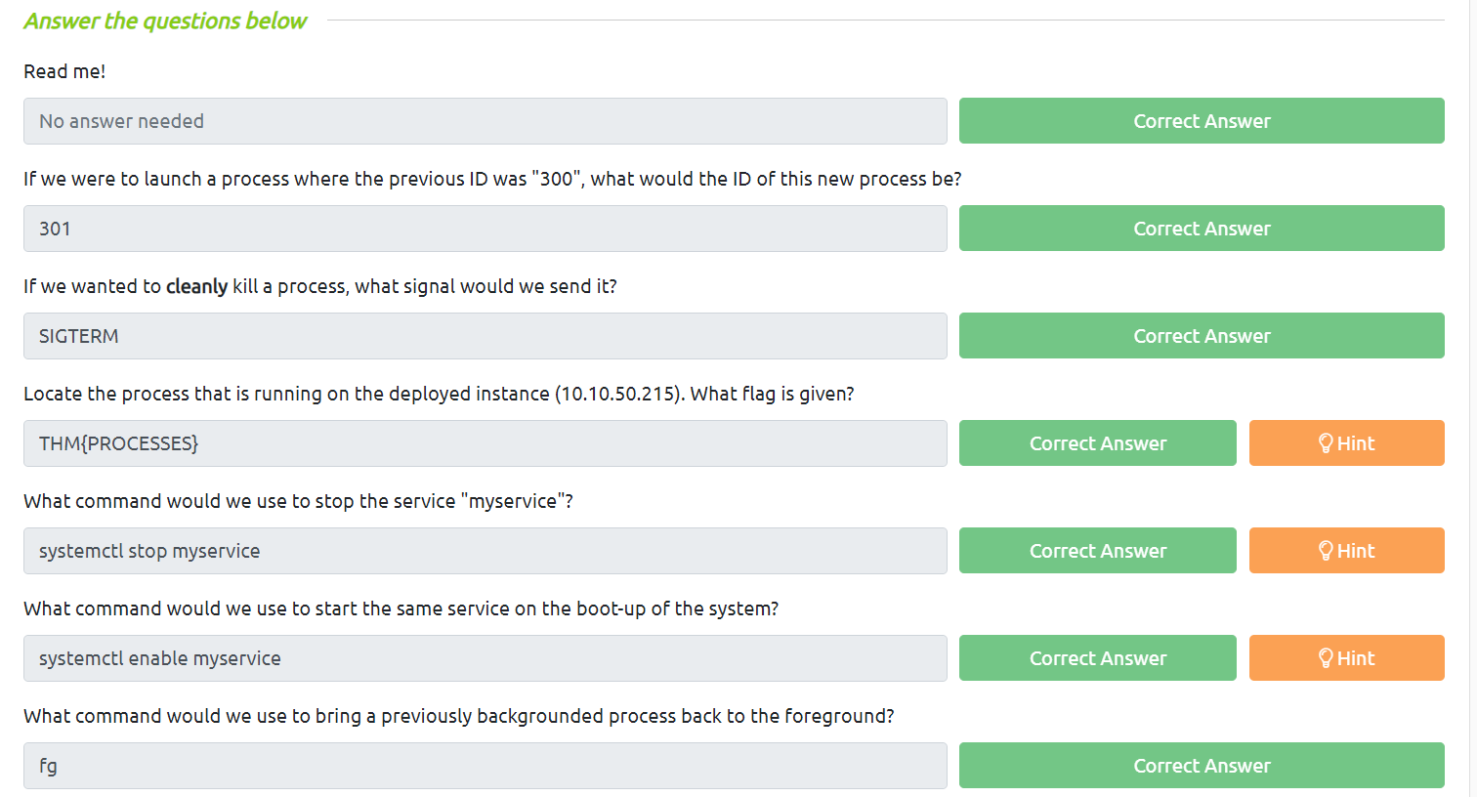

**Task 6: Maintaining Your System: Automation:**

**Crontab – e**

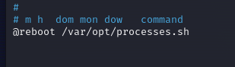

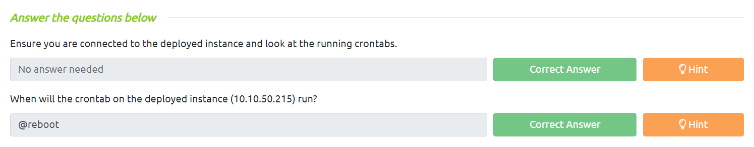

**Task 7: Maintaining Your System: Package Management**

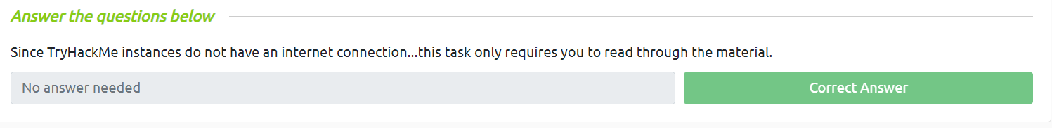

**Task 8: Maintaining Your System: Logs:**

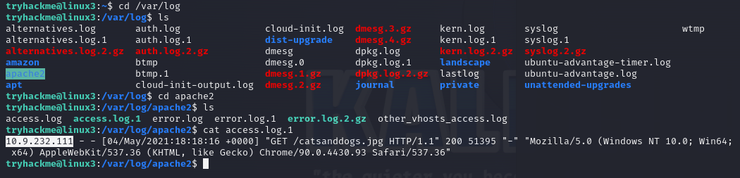 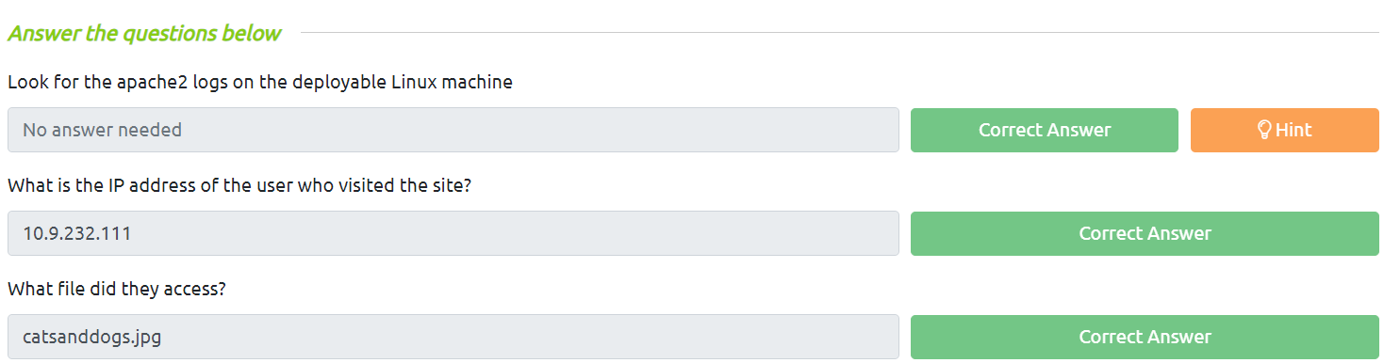

**Task 9: Conclusions & Summaries**

